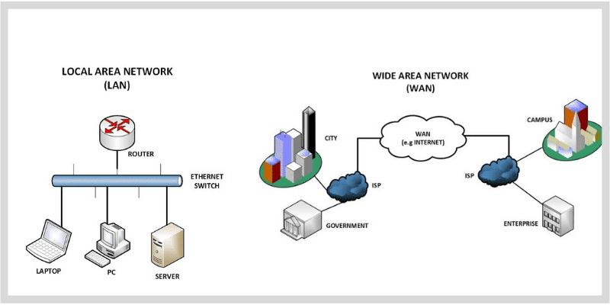

## **Local Area Network (LAN)**

LAN is a group of network devices that allow communication between connected devices. LAN has a shorter propagation delay than MAN as well as WAN. It covers the smallest area such as College, School, Hospital and so on.

## **Wide Area Network (WAN)**

WAN covers a larger area than LAN as well as MAN such as Country/Continent etc. WAN is expensive and should or might not be owned by one organization. PSTN or Satellite medium is used for wide area networks.